What does the following code do?  
  
 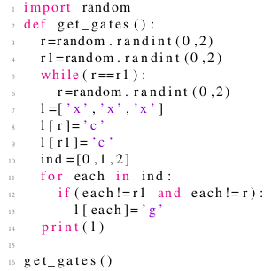

 creates a list where two random elements are ‘c’ and the other element is ‘g’

 creates a list where two random elements are ‘g’ and the other element is ‘c’

 creates a list where one random elements is ‘c’ and the other element is ‘g’

 none of the above

Yes, the answer is correct.  
Score: 1

Accepted Answers:

*creates a list where two random elements are ‘c’ and the other element is ‘g’*

***1 point***

Which of the random experiments from the options does the code represent?  
  
 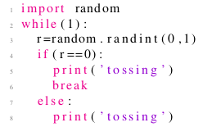

 Tossing a coin once

 Tossing a coin infinite times

 Tossing a coin repeatedly till a head in encountered

 none of the above

Yes, the answer is correct.  
Score: 1

Accepted Answers:

*Tossing a coin repeatedly till a head in encountered*

***1 point***

Which of the random experiments from the options does the code represent?  
  
 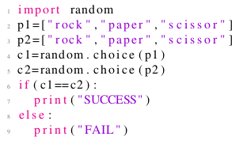

 Prints a success when both people select the same object

 Prints a success when both people select “rock”

 Prints a success when both people select different objects

 None of the above

Yes, the answer is correct.  
Score: 1

Accepted Answers:

*Prints a success when both people select the same object*

***1 point***

For the code below, which of the statement in the options is false?  
  
 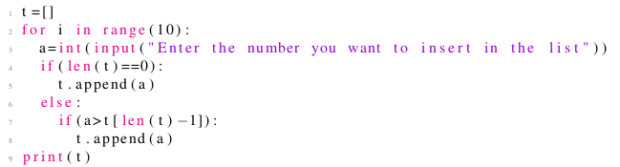

 The loop runs exactly 10 times

 All the integers taken as input from the user need not be in the list l

 The list l consists of exactly 10 elements at the end of the program

 The list l printed in the last line is a sorted list

No, the answer is incorrect.  
Score: 0

Accepted Answers:

*The list l consists of exactly 10 elements at the end of the program*

***1 point***

Which of the random experiments from the options does the code represent?  
  
 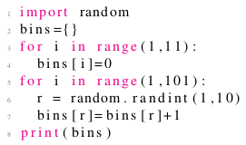

 Placing 100 bins and then throwing 10 balls randomly in these bins

 Placing 10 bins and then throwing 100 balls randomly in these bins

 Placing 10 bins and 10 balls and then throwing 10 balls randomly in these bins

 None of the above

Yes, the answer is correct.  
Score: 1

Accepted Answers:

*Placing 10 bins and then throwing 100 balls randomly in these bins*

***1 point***

Assuming that “bins” represents a dictionary where key is the number of a bin and value represents the number of balls present in the  
    corresponding bin, what is the output of the following code?  
  
 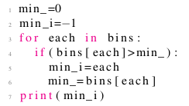

 Displays the maximum number of balls present in any bin

 Displays the number of the bin containing maximum balls

 Displays the number of the bin containing minimum balls

 None of the above

Yes, the answer is correct.  
Score: 1

Accepted Answers:

*Displays the number of the bin containing maximum balls*

***1 point***

Assuming that “bins” represents a dictionary where key is the number of a bin and value represents the number of balls present in the  
    corresponding bin, what is the output of the following code?  
  
 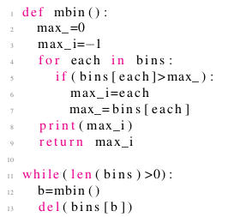

 Displays the maximum number of balls present in any bin

 Displays bins in the ascending order of the number of balls they have

 Displays bins in the descending order of the number of balls they have

 None of the above

Yes, the answer is correct.  
Score: 1

Accepted Answers:

*Displays bins in the descending order of the number of balls they have*

***1 point***

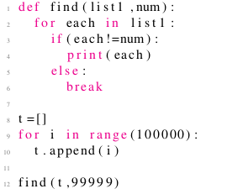  
  
    The above code generates numbers from

 0 to 99999

 0 to 100000

 0 to 99998

 1 to 99998

Yes, the answer is correct.  
Score: 1

Accepted Answers:

*0 to 99998*

***1 point***

Which of the random experiments from the options does the code represent?  
  
 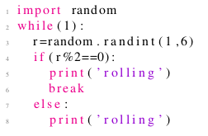

 Rolling a dice once

 Rolling a dice infinite times

 Rolling a dice repeatedly till an odd number is encountered

 Rolling a dice repeatedly till an even number is encountered

Yes, the answer is correct.  
Score: 1

Accepted Answers:

*Rolling a dice repeatedly till an even number is encountered*

***1 point***

Assuming that “bins” represents a dictionary where key is the number of a bin and value represents the number of balls present in the  
    corresponding bin, what plot does the following code generate?  
  
 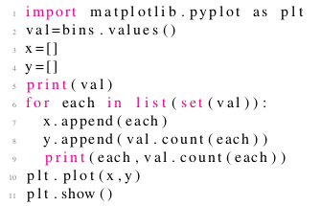

 X axis: Number of balls, Y axis: Number of bins having as many balls as specified by X axis

 X axis: Bin number, Y axis: Number of balls in the bin whose number is specified by X axis

 X axis: Ball number, Y axis: The bin number which contained the ball whose number is specified by the X axis

 None of the above

No, the answer is incorrect.  
Score: 0

Accepted Answers:

*X axis: Number of balls, Y axis: Number of bins having as many balls as specified by X axis*